HARIHARAN 24BAD030
MACHINE LEARNING
SCENARIO 1 – K-NEAREST NEIGHBORS (KNN)
Problem Statement
Predict whether a tumor is benign or malignant based on medical measurements.
Dataset (Kaggle – Public)
Breast Cancer Dataset Dataset Link: https://www.kaggle.com/datasets/yasserh/breast-cancer-dataset
Target Variable: Diagnosis (Benign / Malignant)
Input Feature:
• Radius
• Texture
• Perimeter
• Area
• Smoothness
IN-LAB TASKS (KNN Classification)
1. Import required Python libraries.
2. Load the Breast Cancer dataset.
3. Perform data inspection & preprocessing.
4. Encode target labels.
5. Apply feature scaling (very important for KNN).
6. Split dataset into training and testing sets.
7. Train a KNN classifier.
8. Experiment with different values of K.
9. Predict diagnosis labels.
10. Evaluate performance using: • Accuracy • Precision / Recall / F1 Score
11. Identify misclassified cases.
12. Analyze model sensitivity to K.
Visualization
• Confusion Matrix
• Accuracy vs K Plot
• Decision Boundary (using two features)
OUTPUT:
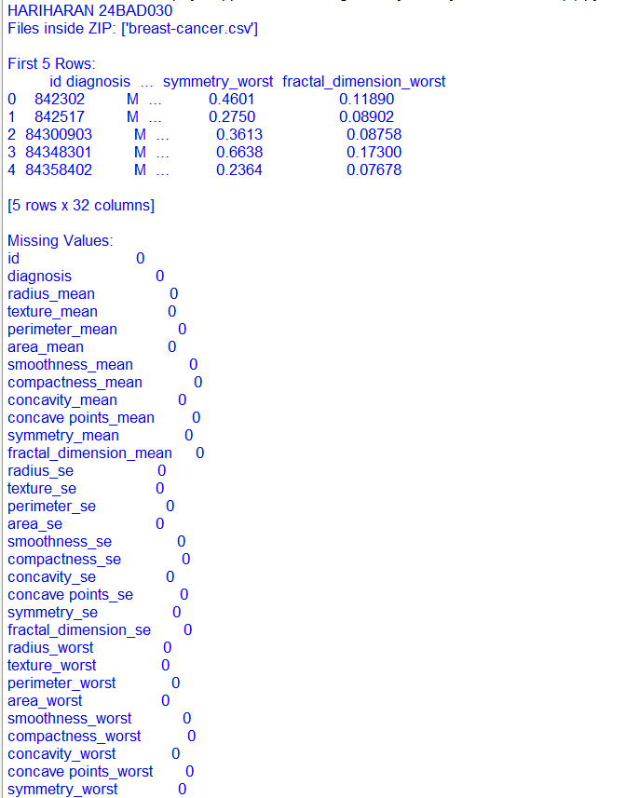
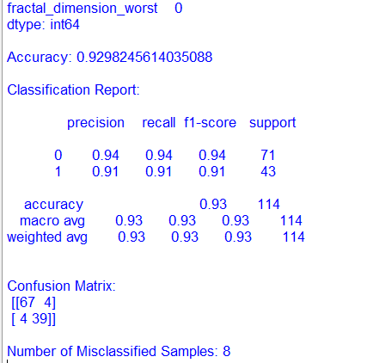

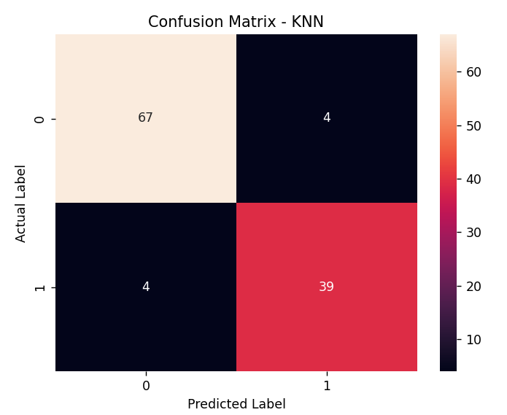
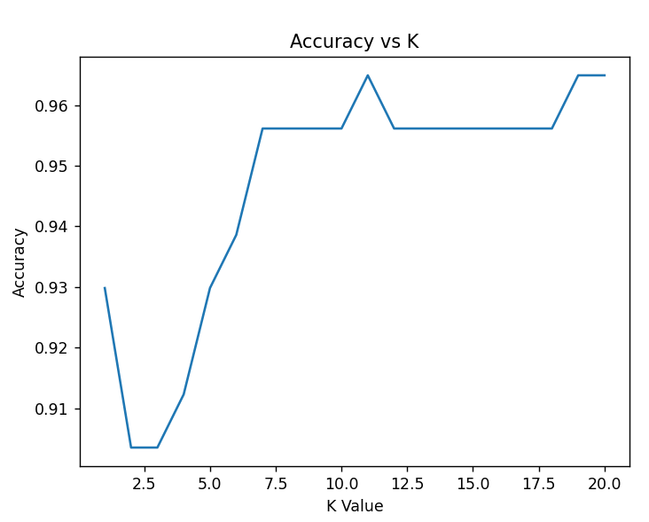
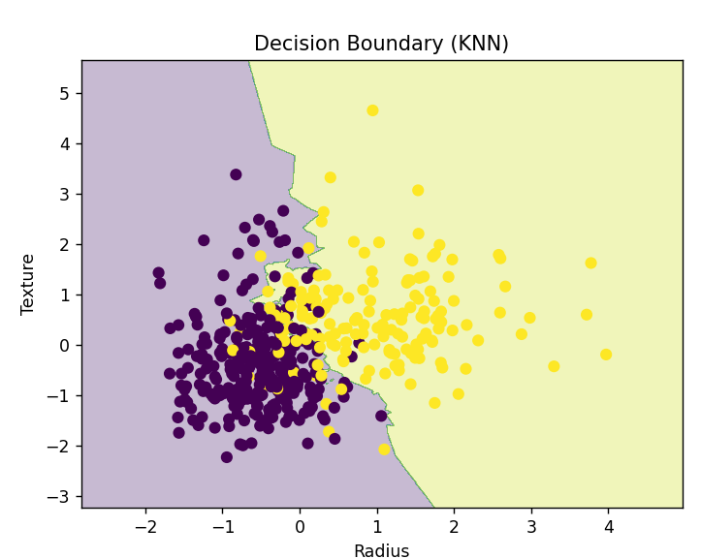

SCENARIO 2 – DECISION TREE CLASSIFIER
Problem Statement
Predict whether a loan application should be approved or rejected.
Dataset (Public / Standard Dataset)
Loan Prediction Dataset Dataset Link: https://www.kaggle.com/datasets/ninzaami/loan-predication
Target Variable: Loan Status (Approved / Rejected)
Input Features
• Applicant Income
• Loan Amount
• Credit History
• Education
• Property Area
IN-LAB TASKS (Decision Tree Classification)
1. Import required Python libraries.
2. Load the Loan Prediction dataset.
3. Perform preprocessing: • Handle missing values • Encode categorical variables
4. Split dataset into training and testing sets.
5. Train a Decision Tree classifier.
6. Experiment with tree depth / pruning.
7. Predict loan status.
8. Evaluate performance using: • Accuracy • Precision / Recall / F1 Score
9. Analyze feature importance.
10. Detect overfitting behavior.
11. Compare shallow vs deep trees.
Visualization
• Confusion Matrix
• Tree Structure Plot
• Feature Importance Plot
OUTPUT:

